Deploy Application using Ansible + CICD pipeline via Github Actions

Create project folder: ansible-cicd

Move to the folder and create folder ansible

Create 2 files under ansible folder

Inventory.yml

all:

  hosts:

    target_host:

      ansible_host: "{{ host_placeholder }}"

      ansible_user: "{{ user_placeholder }}"

      ansible_ssh_private_key_file: ~/.ssh/id_rsa

create playbook.yml

---

- name: Test Connection with instance and install NgInx

  hosts: all

  become: yes

  tasks:

    - name: Ensure Nginx is installed

      apt:

        name: nginx

        state: present

        update_cache: yes

    - name: Start and Enable Nginx

      service:

        name: nginx

        state: started

        enabled: yes

Create .github/workflows/deploy.yml

name: Deploy with Ansible

on:

    push:

        branches:

            - main

jobs:

    deploy:

        runs-on: ubuntu-latest

        steps:

            - name: Checkout Repo

              uses: actions/checkout@v4

            - name: Set up Python and Ansiblec:\Users\NEW\Downloads\testsonam.pem

              run: |

                sudo apt update

                sudo apt install -y python3-pip

                pip3 install ansible

            - name: Add SSh key and set permission

              run: |

                mkdir -p ~/.ssh

                echo "${{ secrets.ANSIBLE_PRIVATE_KEY }}" > ~/.ssh/id_rsa

                chmod 600 ~/.ssh/id_rsa

                ssh-keyscan -H ${{ secrets.HOST }} >> ~/.ssh/known_hosts

            - name: Replace Placeholders in my inventory

              run: |

                sed -i "s/{{ host_placeholder }}/${{ secrets.HOST }}/" ansible/inventory.yml

                sed -i "s/{{ user_placeholder }}/${{ secrets.REMOTE_USER }}/" ansible/inventory.yml

            - name: Run Ansible Playbook

              run: |

                ansible-playbook ansible/playbook.yml -i ansible/inventory.yml

Now Very important setup your github Repository

Go to your repo settings

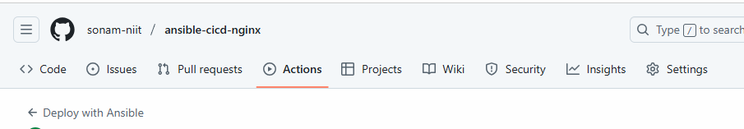

Click on settings

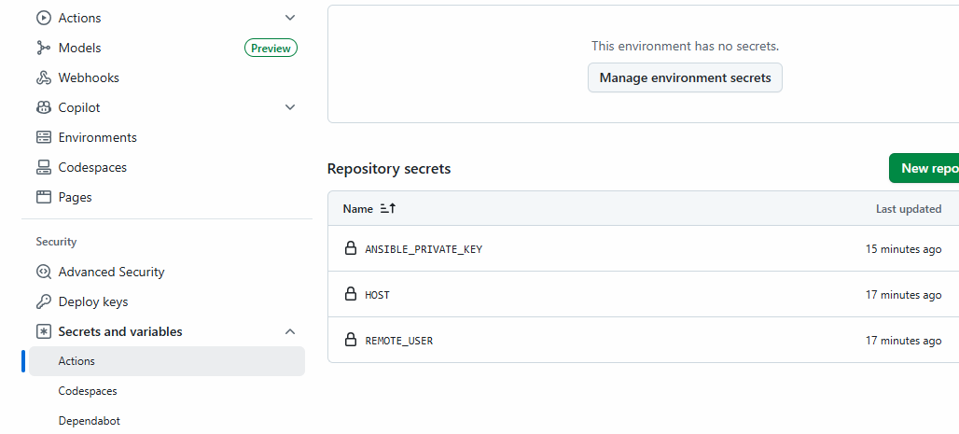

Click on secrets and variables

Actions 🡪 create new Repository secret

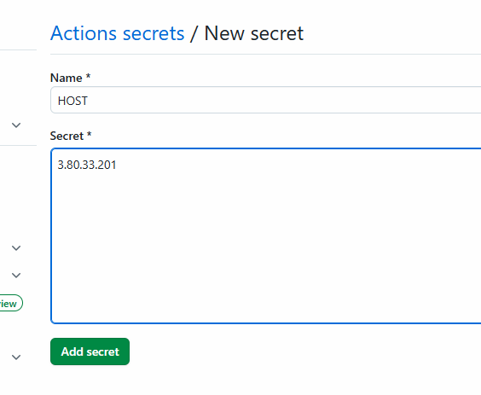

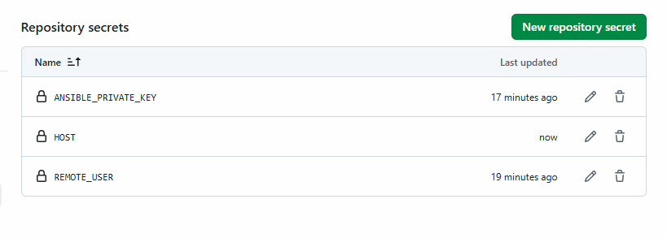

For Key you can copy paste the content of your .pem file

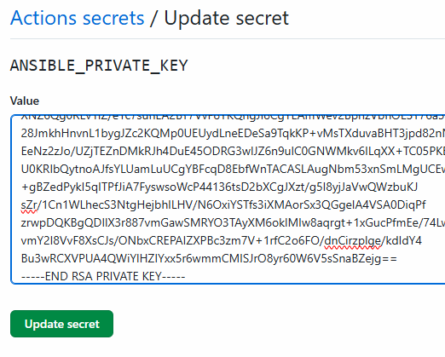

Then just do git push.

Check Actions

For entire project structure and output you can check below repo link

<https://github.com/sonam-niit/ansible-cicd-nginx>

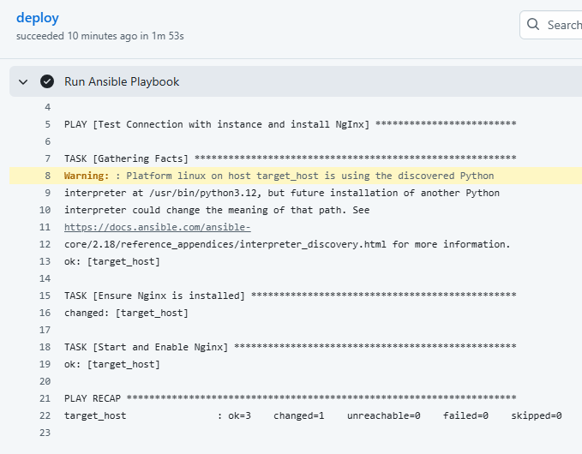

If all executed successfully then you can see the default page of NgInx with public IP (make sure port 80 is open in your security group)

